
Title Setup of C5000 Volume register
Version 1.0
Date:02/11/2022
Compac Industries Ltd.
52 Walls Road. Penrose. Auckland 1061. New Zealand.
PO Box 12 417. Penrose. Auckland 1642. New Zealand.
Tel: +64 9 579 2094 Fax: +64 9 579 0635 info@compac.co.nz
www.compac.co.nz
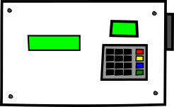 | Master/Single Online Volume Resister (litres only)  Unit connecting to CompacOnline.  Options  - Litres preset  - Odometer  - Card Swipe  - HID  - Compac Mifare Tag  - Pin Auth  - Pin number  - User ID
 | Master/Single Online Volume Resister (Retail only)  The unit connecting to CompacOnline.  Options  - Dollars preset  - Odometer  - Card Swipe  - HID  - Compac Mifare Tag  - Pin Auth  - Pin number  - User ID

Controller Setup
For the C5000 Volume Register to Display on the Keypad the controller needs to have the pumps setup with a bay number and C5000 display enabled
This can done on the keypad or manually editing the PSC file

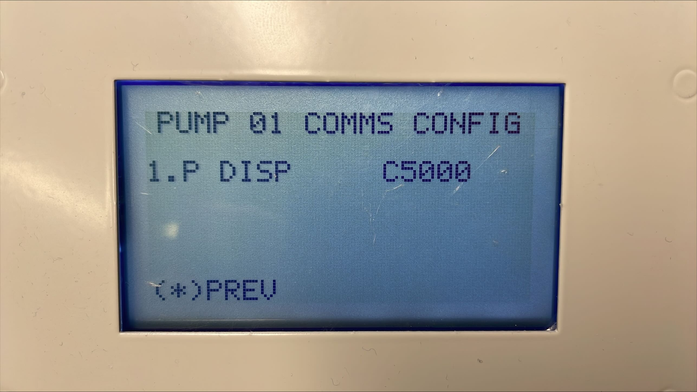
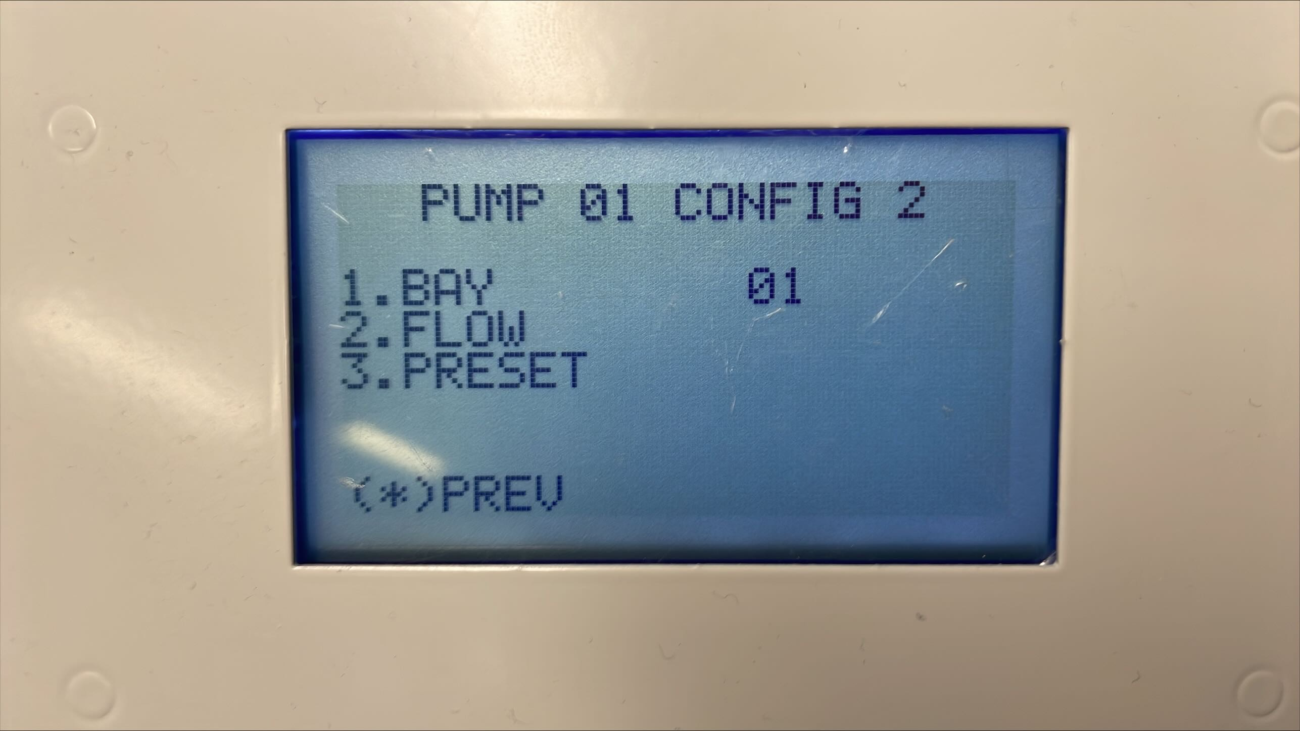

Bay number is at address 0x16

C5000 Display 0x17

Also need to set the pump coms type to compac96_7D. If there is other dispensers you might have to set the pump compac24_7D but bear in mind that the pinpad display will act slower on the volume register.

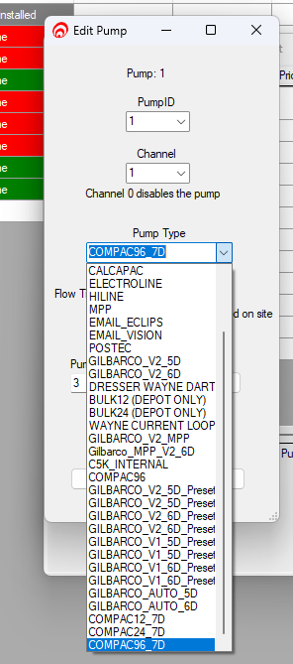
If you have HID or card reader you need to select in the type so that the volume register will prompt the right prompt. The default is PASS CARD.

Litres preset
By default the volume register will prompt for dollars preset but if you require liters preset
you need to enable the following flag. Don’t forget to click the pass valve back
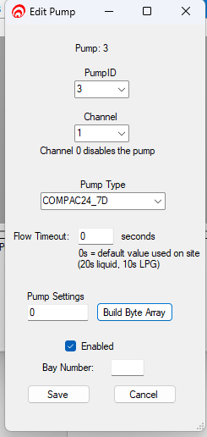 | 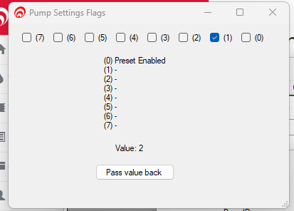

Volume register Setup
Need to make sure that Volume register is in 7 digit mode. This can be set through the pinpad or the k factor button

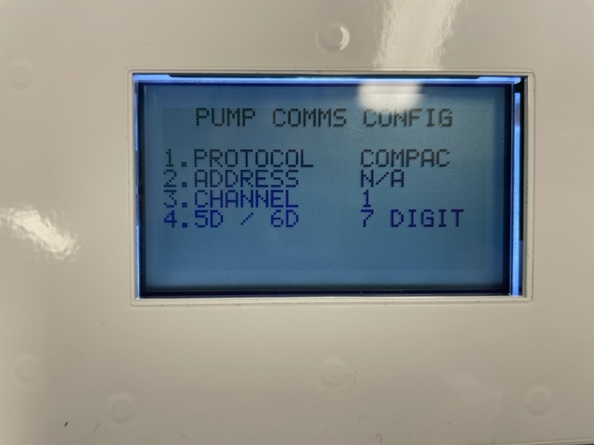 | 